**Software overview**

1. Login Page
2. Navbar Tabs
3. Map
   1. Recent Activity
   2. Zoom in/out
   3. Screen recorder

ADS USER'S MANUAL INDEX

Version 1.0

1. Radar History
   1. Detected object history
   2. Filter and Download Button
2. Jammer History
   1. jammer on/off states
   2. Filter and Download Button
   3. Drone dialogue box
   4. Radar status
   5. Jammer status
   6. Manual circle coordinates
3. Logout

**A**nti - **D**enial **S**ystem

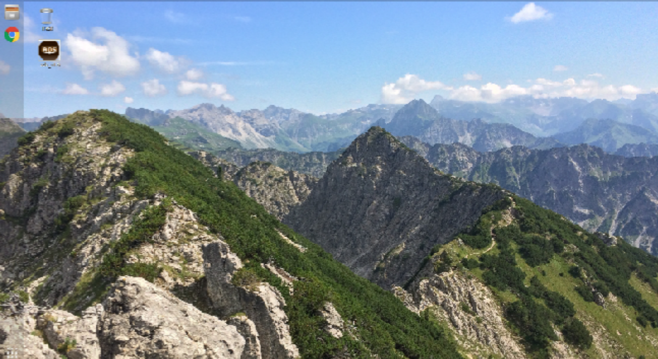

Double click on this icon to open the web application (ADS).

# Login Page :

Enter your credential and click on sign-in button.

## After login into the ADS application user will find 3 tabs as below :-



ADS

# 3.Map

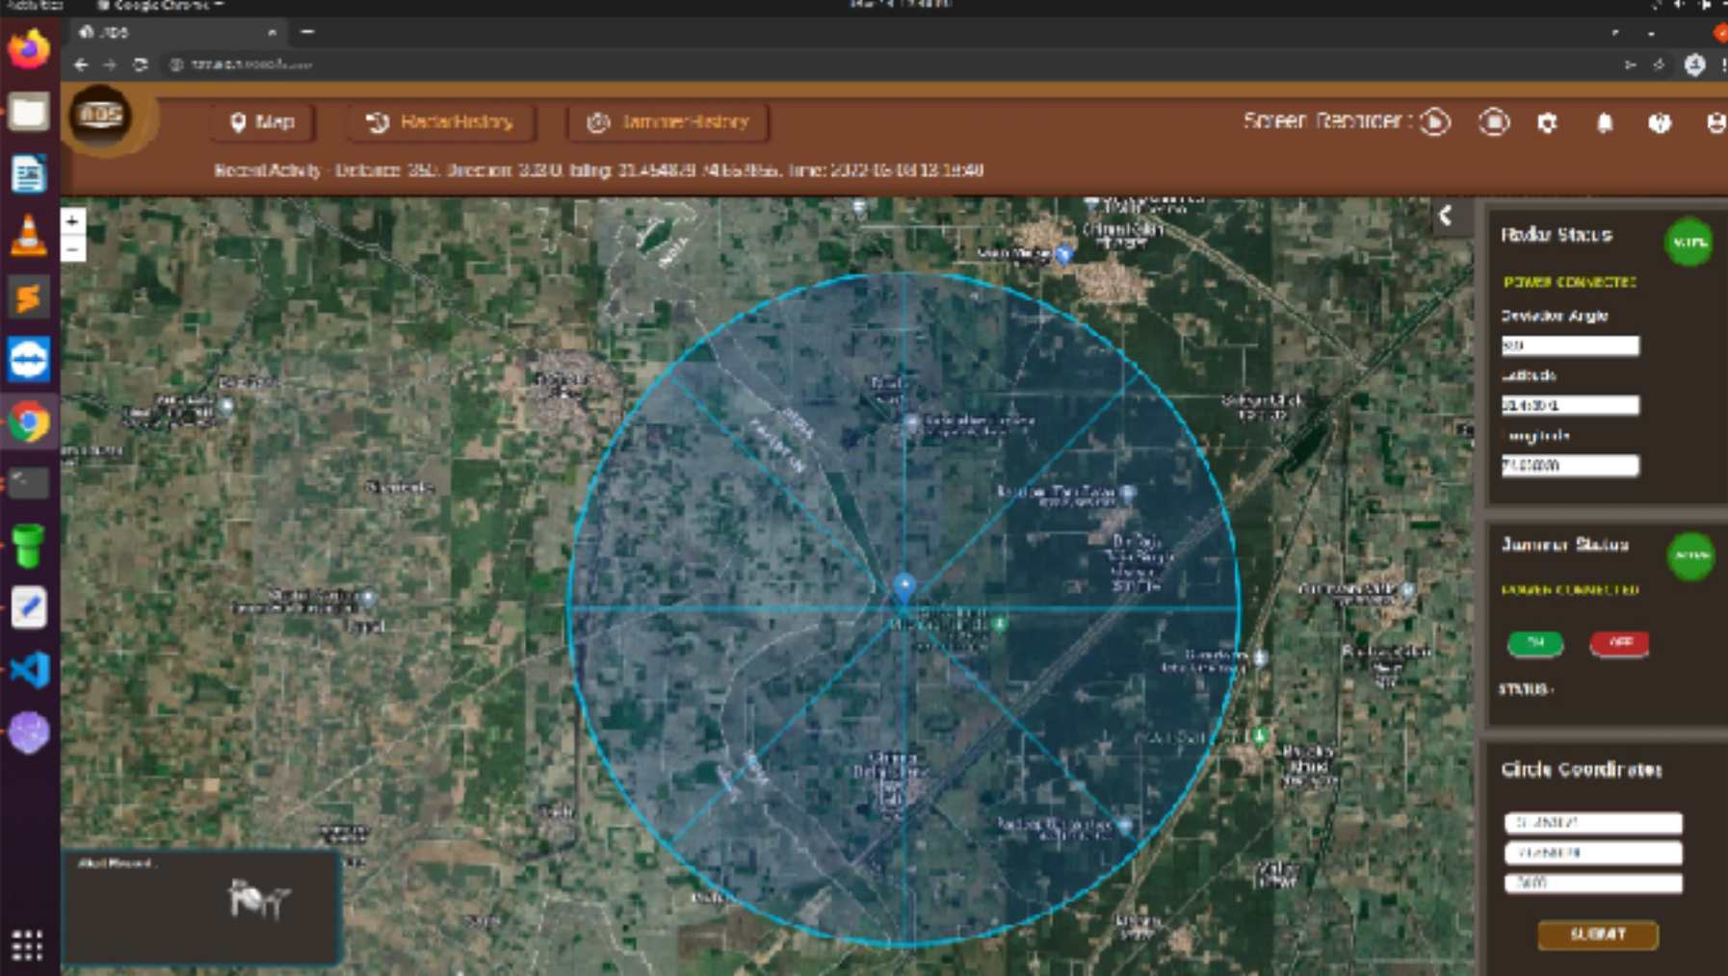

In this section, user will find features as below:-

* 1. Recent activity
  2. Map Zoom in and zoom out.
  3. Screen recorder functionality.
  4. In the dialog box showing current detected drone name.
  5. Radar Status:-
     1. In the radar status there is an indicator button which showing whether radar is active or not active.
     2. Showing radar current location with latitude and longitude.
     3. Radar's deviation angle
  6. Jammer Status:-
     1. In the jammer status there is an indicator button which showing whether jammer is active or not active.
     2. There is two button ON and OFF which operate jammer.
  7. Circle Coordinates:-
     1. User can create manually circle by entering latitude and longitude and radius(in mtrs) and click on submit button.

# Radar History

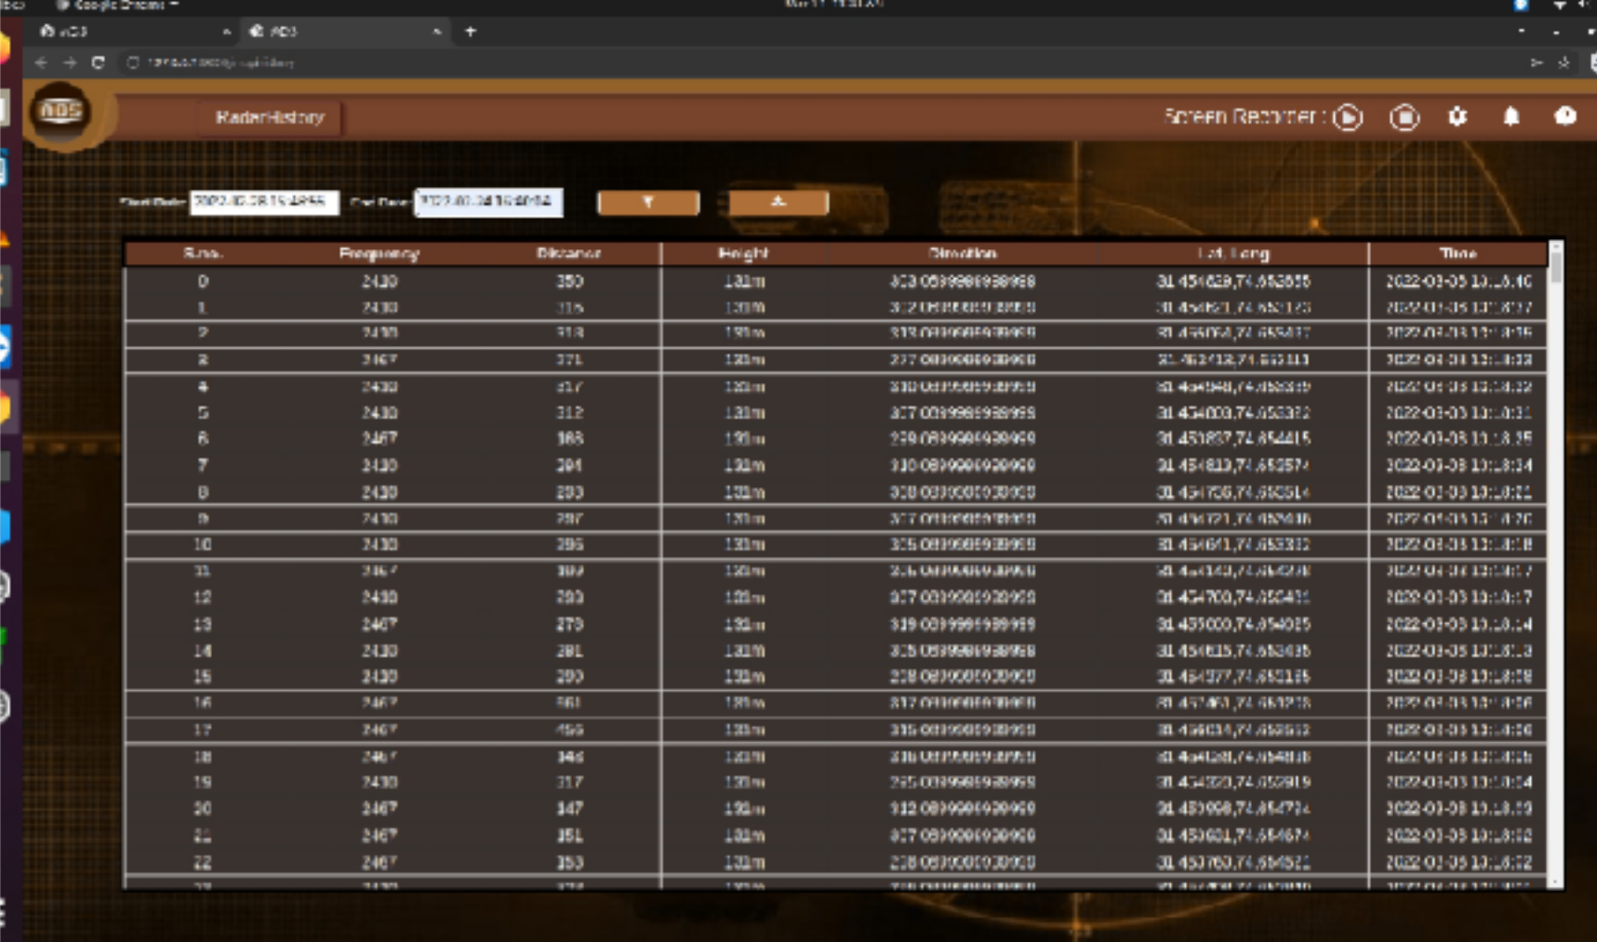

* 1. User will find in this section detected drone history with serial number, frequency, distance, height, direction, lat-long and date time.
  2. User can filter the data with Start and End date time, also can download

# Jammer History

* 1. User will find in this section jammer ON/OFF states.
  2. User can filter and download the jammer states.

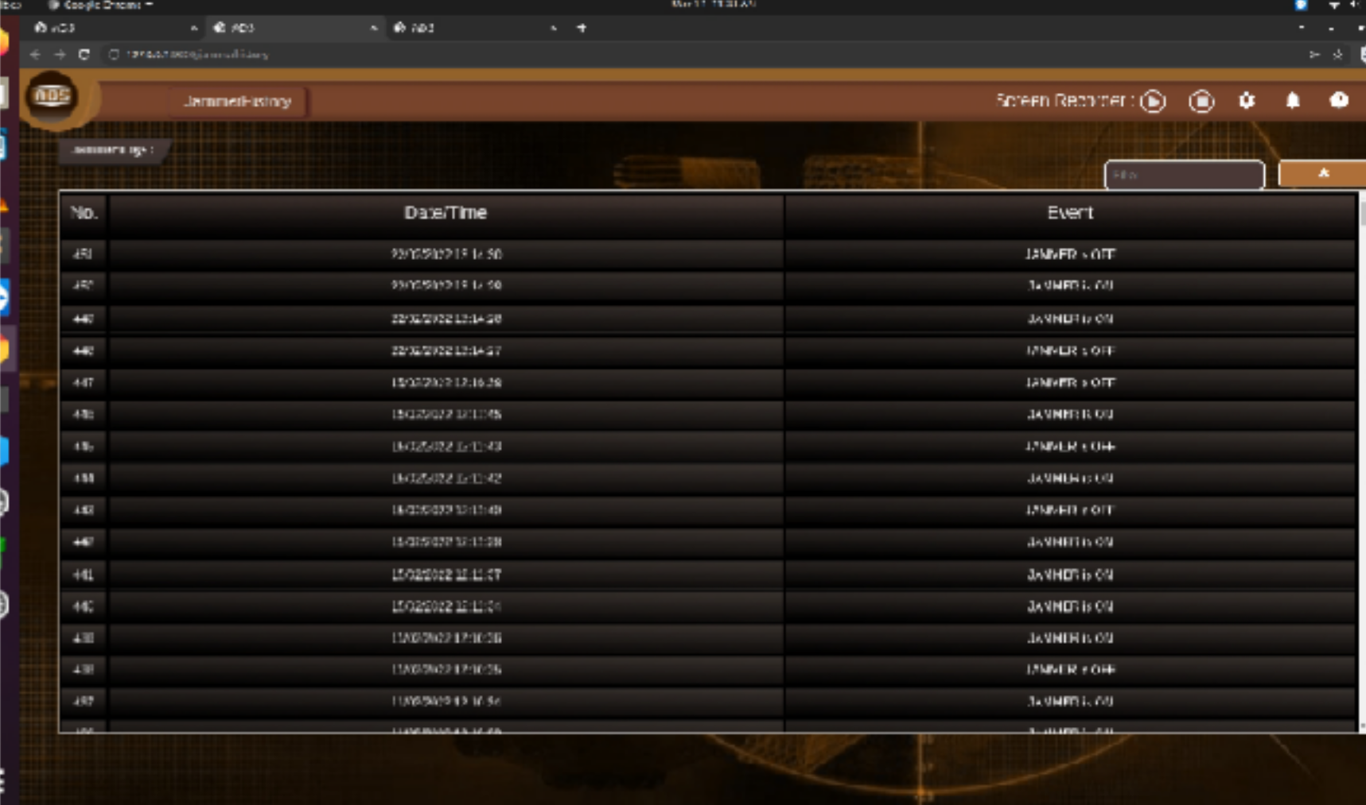

1. **Logout**